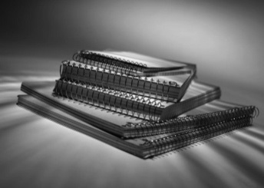

All Classes | - Pencils – lots!  - Highlighters
Social Studies | - One Inch Binder  - 1 set of 5 dividers
Science | - 1” Binder  - White Lined Filler Paper
Math | - One (1) inch 3 ring binder with dividers
Literacy | - Single subject spiral notebook  - Pocket folder

